FOR IMMEDIATE RELEASE CONTACT: Stephanie Wuorenma
Phone: 202-446-2138
Office: Terrebonne, OR (Pacific Time Zone)
Email: mediarelations@agreenerworld.org
Website: agreenerworld.org

FIRST FARM IN ASHE COUNTY, NC, AWARDED TOP ENVIRONMENTAL AND ANIMAL WELFARE CERTIFICATION
--The Abandoned Dog uses sustainable agriculture methods to earn Certified Animal Welfare Approved by AGW certification for its pasture-raised goats--
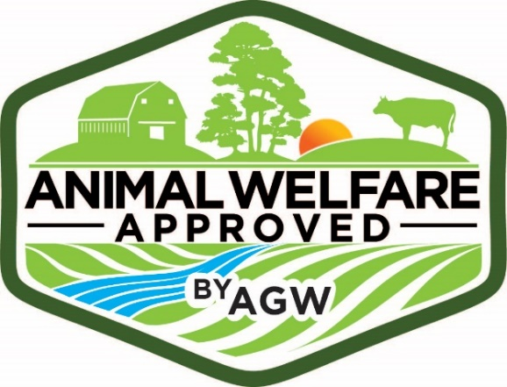
LANSING, NC (DATE)--The herd of goats at The Abandoned Dog is now Certified Animal Welfare Approved by A Greener World (AGW). A Certified Animal Welfare Approved by AGW source farm for goats, The Abandoned Dog is approved to raise and sell goats to other AGW-certified farms.
This certification and food label lets consumers know these animals are raised outdoors on pasture or range in accordance with the highest animal welfare standards in the U.S. and Canada, using sustainable agriculture methods on an independent farm. Consumer Reports has rated Certified Animal Welfare Approved by AGW as a “highly meaningful” label for farm animal welfare, outdoor access and sustainability--and the only animal welfare certification in which they have confidence.

Like other Certified Animal Welfare Approved by AGW farmers across the country, Jeff and Nona Cullen recognize the growing consumer interest in how animals are raised on farms. Managing animals outdoors on pasture or range has known benefits for animals, consumers and the environment.

The farm’s herd of Kiko meat goats browse the mountain brush and forage, a natural food source for the animals. The Cullens strive to breed hearty, parasite resistant, healthy Kiko goats that are able to thrive with minimal human interference. Nona Cullen of The Abandoned Dog says they chose to become certified by AGW because, ultimately, “Having the certification and label of Certified Animal Welfare Approved by AGW helps to identify to potential buyers the hard work that we have put forth into our farm and animals.”

AGW Executive Director Andrew Gunther says,

“We’re proud to certify farms like The Abandoned Dog [Insert link to Farm Profile] that have demonstrated their commitment to transparency and verified, high-welfare, farming practices. These stewards of the countryside are quite literally building a greener world while farming in ways that benefit animals, society and the environment. We’re honored to work with them.”

Certified Animal Welfare Approved by AGW goats are sold direct from the farm (open daily from 9 AM to 6 PM) and at Kiko breeder sales. Jeff and Nona have strict criteria that they’ve formulated for future breeding stock, so what is offered may change from year to year. Contact the farm for detailed information about goat sales. For more information, contact Nona Cullen at mrsjmcullen@yahoo.com and 336-384-1045 or visit theabandoneddogkikogoats.com. You can also follow the farm on Facebook.

ABOUT A GREENER WORLD
A Greener World (AGW) identifies, audits, certifies and promotes practical, sustainable farming systems by supporting farmers and ranchers and informing consumers. AGW’s growing family of trusted certifications includes Certified Animal Welfare Approved by AGW, Certified Grassfed by AGW and Certified Non-GMO by AGW. Each program is designed to have positive and measurable impacts on the environment, society and animals, and to encourage truly sustainable farming practices. AGW’s standards and procedures are robust, transparent and achievable.
A nonprofit funded by public donations and membership, AGW offers a range of resources to help people make informed food choices, including an Online Directory of certified farms and products and Food Labels Exposed--a definitive guide to food label claims (available in print, online, and as a smartphone app). For more information visit agreenerworld.org.
###

